FOR OFFICE USE ONLY
Location: ___________________________
Permit Application No.________________
Date: ______________________________
Zoning: ____________________________
Village of West City
1000 Blakely St.
West City, IL 62812

Office of the Zoning Administrator, Scott Sandusky

Building or Sign Permit Application
Prox. Cost $___________________
Owner(S) Name(s)______________________________________________________________________
Address__________________________________City_________________________________________
Telephone_______________________________
Mail permit to_________________________________________________________________________
Applicant(s) Name(s)____________________________________________________________________
Address______________________________________________________________________________
Telephone________________________________
Property interest of Applicant (contract purchaser, etc.) _______________________________________
INSTRUCTIONS TO APPLICANTS:
All information requested must be completed on this application. Applicants are encouraged to visit this office and every assistance will be given in filling out this form. If possible, please call 618-200-1402 for an appointment to avoid delays. Please mail or drop application to: Scott Sandusky, Zoning Adm., and 1000 Blakely St., West City, IL 62812.
Application is hereby made for a PERMIT and a CERTIFICATE OF OCCUPANCY AS REQUIRED under the COMPREHENSIVE ZONING ORDINANCE of the Village of West City for the erection, moving, or alteration, and use of all the following statements and any attached maps and drawings as a true description of the proposed new or altered uses and/or buildings. The applicant agrees that the permit applied for, if granted, is issued on the representations made herein and that any permit issued may be revoked with-out notice on any breach of representations or conditions.
- LOCATION OF PROPOSED CONSTRUCTION:
Address of proposed construction___________________________________________________
Legal description of property (description by metes and bounds or lot number, block number and name of subdivision) ________________________________________________________________
_____________________________________________________________________________________
_____________________________________________________________________________________
_____________________________________________________________________________________
_____________________________________________________________________________________
Construction located in _____________________________Zoning District

- PROPOSED CONSTRUCTION:
A( ) New Building: B( ) Alterations or additions to existing buildings
C( ) Other_____________________________________________________________________

- USE OF EXISTING AND PROPOSED STRUCTURES:
Existing use (commercial, industrial, residential, agricultural, etc.) _________________________
Proposed use (commercial, industrial, residential, agricultural, etc.) _______________________

- PLANS AND SPECIFICATIONS:
- PLANS. A plat drawn to scale is attached and shows the following:
- Actual shape and size of lot or property.
- Location, ground area dimensions, and identification of use of all (existing and proposed) buildings, structures, driveways, parking areas, etc.
- Dimensions of front, side, and rear yards.

- SPECIFICATIONS. For each building, structure, or use (existing and proposed) identified on the plat, give the following information if applicable:

Structure | Height in Feet | No. of Stories | No. of Dwelling Units | No. of Employees | No. of Parking Spaces
Existing
Proposed

- Survey. A survey is attached: __________Yes ____________No
It is understood that any permit on this application will not grant any right or privilege to erect any structure or to use any premises described for any purpose or in any manner prohibited by the Zoning Ordinance, or by other ordinances, codes or regulations of the Village of West City. The applicant further agrees to notify Zoning Administrator at the stages of construction stated on the permit if granted. The Zoning Administrator shall upon completion of construction inspect the premises and issue or refuse a Certificate of Occupancy. It is further understood that unless a substantial start on construction is made within six (6) months, and unless substantial progress is made within one (1) year, and unless construction is completed within two (2) years from the date of issuance of this permit (unless this period should be extended upon such application being received from the applicant), this permit shall become null and void.
_________________________________
(Signature of Applicant)
_________________________________
(Address of Applicant)
Date: _________________________________

Witnessed: ____________________________
_________________________________________
(Signature) Owner or Authorized Agent
This institution is an Equal Opportunity Provider and employer.

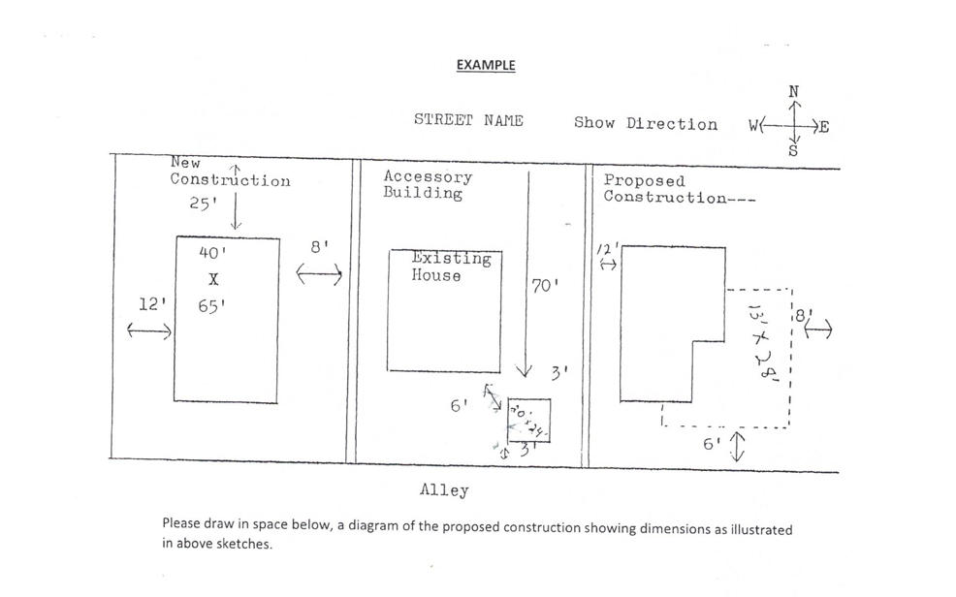

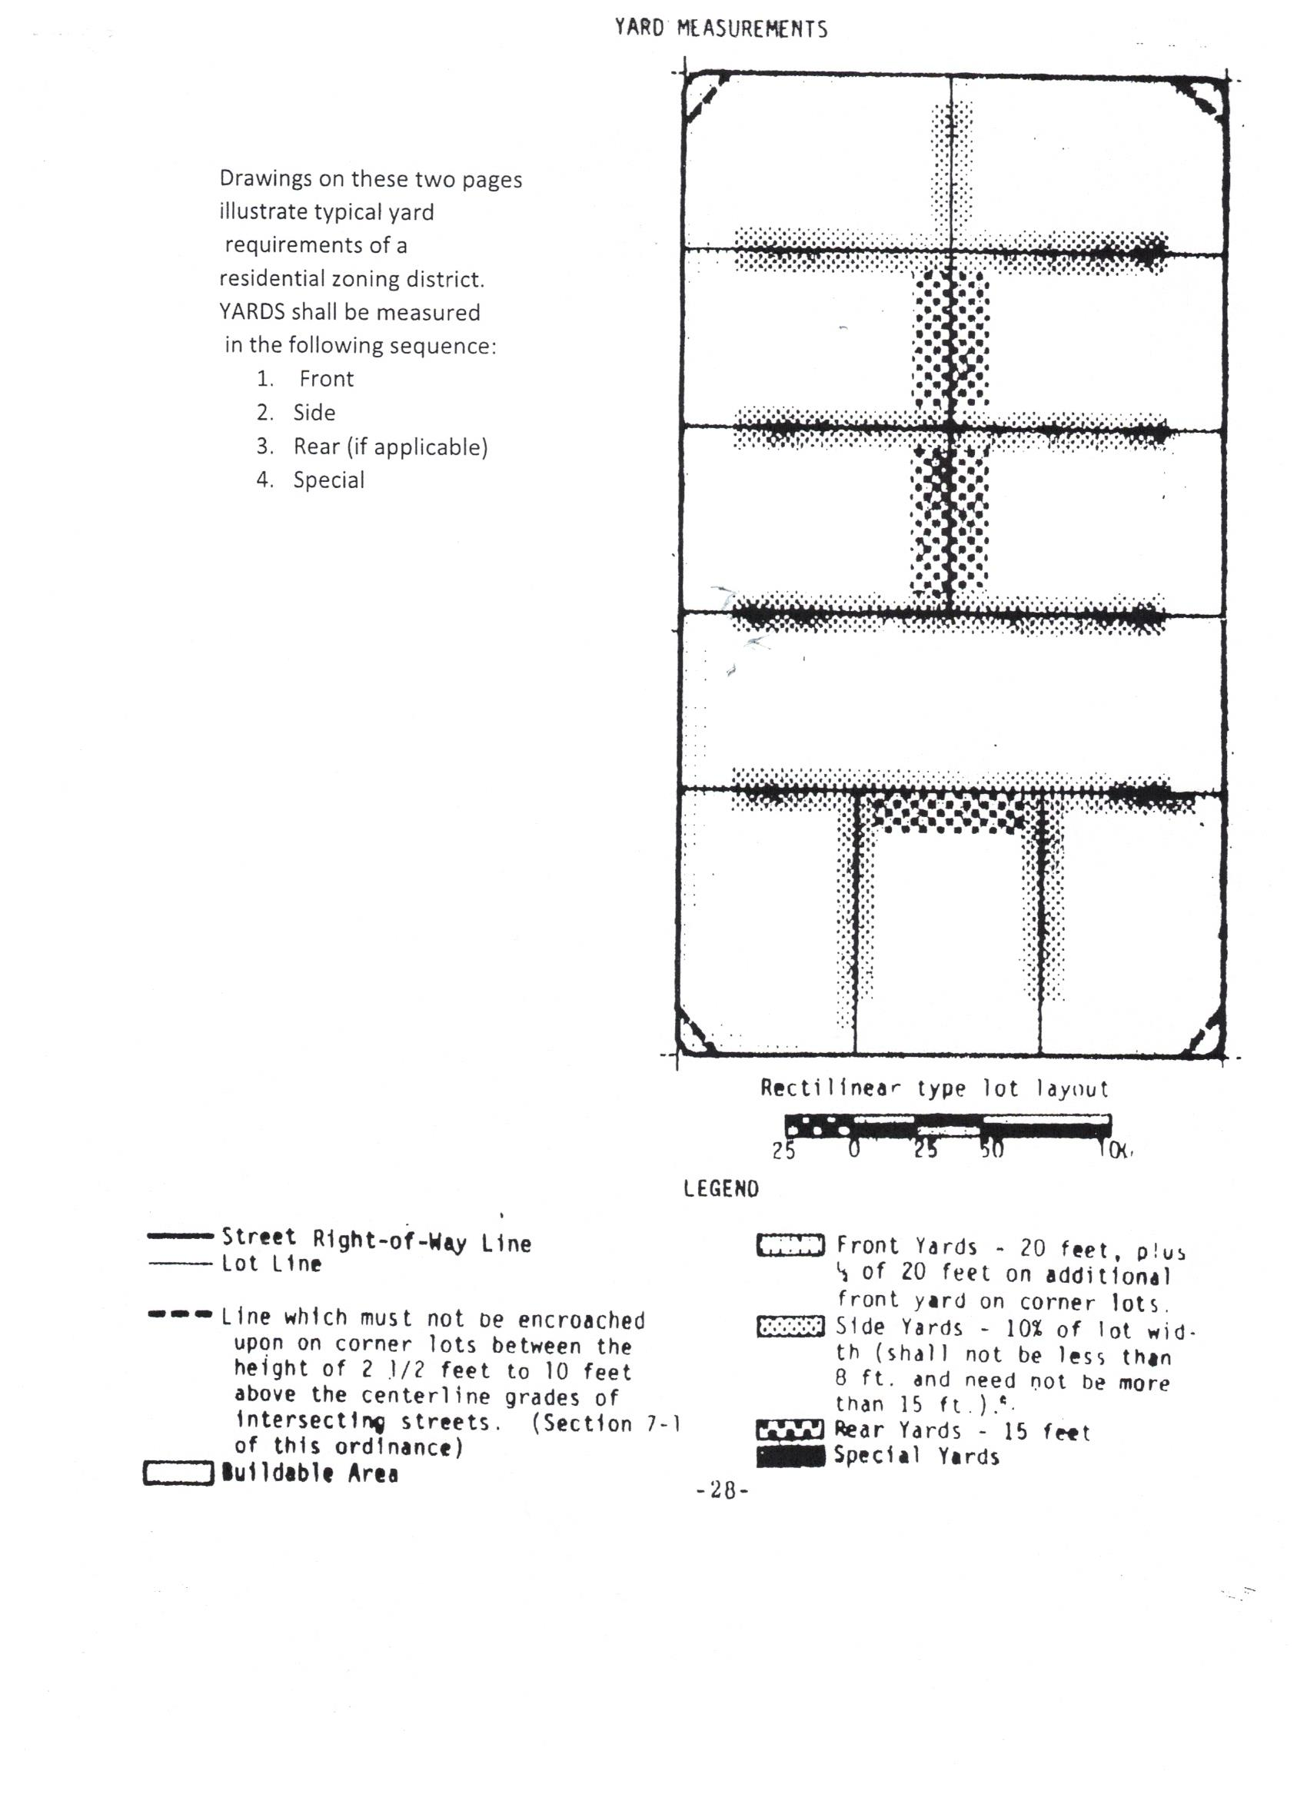

OFFICE USE ONLY

Permit issued ( ) Permit No.: __________________ Date: ________________
Permit denied ( ) Cause for denial:____________________________________

________________________________________________________________________
1st Inspection Requested: Date __________________ Inspection Made:
Date: __________________ Name of Inspector__________________________
2nd Inspection Requested: Date __________________ Inspection Made:
Date: __________________ Name of inspector _________________________
3rd Inspection Requested: Date __________________ Inspection Made:
Date: _________________ Name of inspector __________________________
Certificate of Occupancy issued ( ) Certificate No. _________ Date: _______________
Certificate of Occupancy denied ( ) Cause: ___________________________________
________________________________________________________________________
________________________________________________________________________

_______________________________
Zoning Administrator

